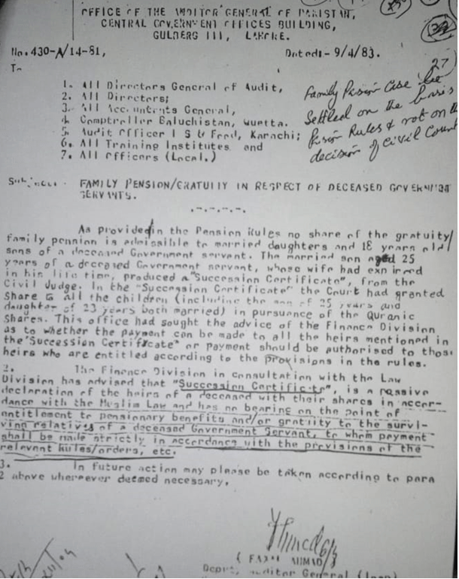

**Notification of AGP Regarding Pension and Inheritance**

**OFFICE OF THE AUDITOR GENERAL OF PAKISTAN**

**CENTRAL GOVERNMENT OFFICES BUILDINGS,**

**GULBERG III, LAHORE**

No.430-A/14-81  Dated 9/4/83.

To

1. All Directors General of Audit,
2. All Directors
3. Comptroller, Baluchistan, Quetta
4. All Accountants General
5. Audit Officer I S & F, Karachi
6. All Training Institutes, and
7. All Officers (Local.)

**Subject:      FAMILY PENSION/GRATUIT IN RESPECT OF GOVERNMENT SERVANT**

As provided in the   Pension  Rules,  no share of the gratuity/family pension is admissible to the married daughters and   18   years old sons of a    deceased     Government servant. The married son aged  25 years of a deceased  Government servant, whose wife had expired in his lifetime, produced a  “Succession Certificate” from the Civil Judge. In the    “Succession Certificate,”      the     Court had granted share to all the children      (including the son of    25   years and daughter of     23     years both married)     in pursuance of the   Quranic Shares. This office had sought the advice of the Finance Division as to whether the payment they should make to all the heirs mentioned in the  “Succession Certificate” or to those heirs who have entitlement according to the provision in the rules.

1. The Finance  Division in consultation with the Law Division has advised that “Succession Certificate”  is a passive declaration of the heirs of a deceased with their shares in accordance with the Muslim Law and has no bearing on the point of entitlement to [pensionary benefits](https://www.glxspace.com/2018/02/09/pension-benefits-compulsory-retirement/) and/or gratuity to the surviving relatives of a deceased Government Servant, to whom payment shall be made strictly in accordance with the provisions of the relevant rules/orders,   etc.
2. In the future action may please take according to para  2  above wherever deemed necessary.

Sd/-

