This article relates to good news for pre-2001 pensioners. You will read in detail the importance of this article for the pensioners retired before 2001. Today I am narrating how some pre-2001 pensioners have succeeded in obtaining favorable orders from Federal Service Tribunal Islamabad for the actual payment of all pension increases from 01 Dec 2001 up to restoration date, and actual payment of arrears.  So far these increases were given only on the notional (and not actual) basis to determine pension amount upon restoration.

**Very important and good news for pre-2001 pensioners**

* Governments have so far not paid increases on Gross Pension from 01 Dec 2001 till the date of restoration. These increases are calculated on a notional basis only to determine the amount of pension payable from the date of restoration.  In simple words, increases have not been paid by governments on commuted part of pension from 01 Dec2001 till restoration date.
* It will be recalled that the non-applicability of [2001-payscales-cum-pension scheme](https://www.glxspace.com/2020/10/28/legal-aspects-of-2001-payscales-cum-pension-scheme/) on pre-2001 pensioners was previously explained on the Galaxy World website.
* Some pre-2001 pensioners approached the federal government with the request that since the 2001-scheme did not apply to them, the 1994 policy of giving [increases on Gross Pension](https://www.glxspace.com/2017/02/08/increases-gross-pension-payment-increased-pension-date-restoration-punjab/) should be continued, and all increases are allowed on Gross Pension (including the [commuted part of a pension](https://www.glxspace.com/2019/08/23/how-to-calculate-pension-and-commute/)). This request was not acceded to, and consequently, several cases were filed with the Federal Service Tribunal.
* Orders have since been issued by the Federal Service Tribunal on 18 Jan 2022 to the effect that it is totally unjustified to apply 2001 rules to the pensioners who retired in 1994 payscales. Appeals have been accepted, and the government has been directed to apply the 1994 rules continuously irrespective of any future amendments.  Pension of the Appellants has now to be calculated afresh based on pension rules of 1994, and they are entitled to all the back (arrears) benefits on such recalculation of pension.

**Entitled to Actual Payment of Increases**

* This is very good and very important news for the pre-2001 pensioners. They have been declared entitled to actual payment of increases (instead of notional increases) for the period 01 Dec 2001 to restoration date.
* Government has yet time to approach the Supreme Court against this decision of the FST. The position will be clear in a month or so whether the government intends to go into appeal. Another issue is the extension of the benefit to all equally-placed pre-2001 pensioners.  It will be recollected that Supreme Court has already declared that the benefit allowed to litigating persons needs to be extended to other pensioners also who did not enter into litigation (instead of compelling them also to indulge in litigation).
* Copy of Order issued by the FST on 18 Jan 2022 is given below. For further information or discussion, please get in touch with Agha Amir on emails [amir_agha@hotmail.com](mailto:amir_agha@hotmail.com) OR [amir.ahmad@aksa-sds.com](mailto:amir.ahmad@aksa-sds.com) and WhatsApp number 0300-9800246.

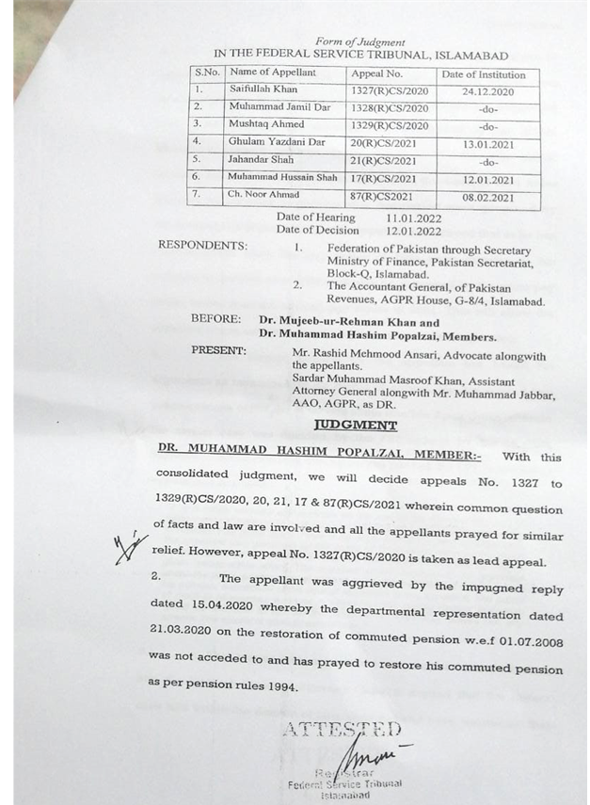

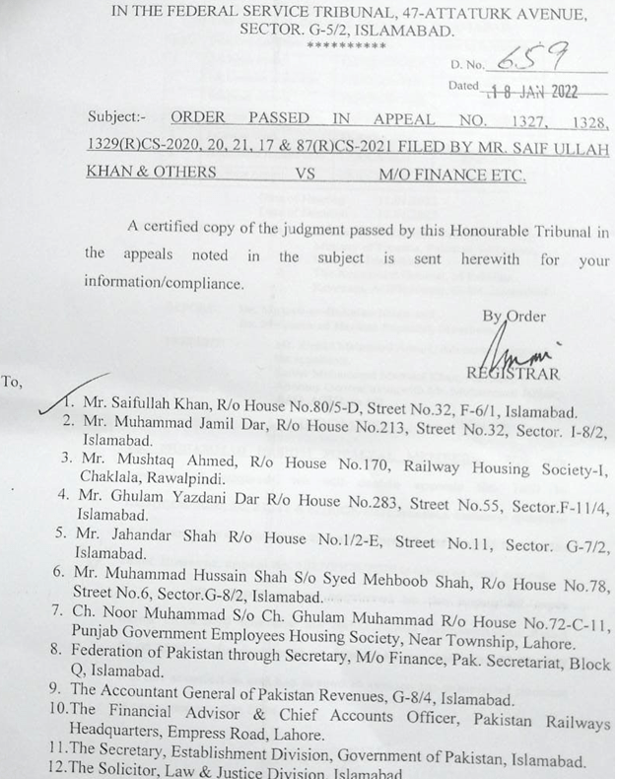

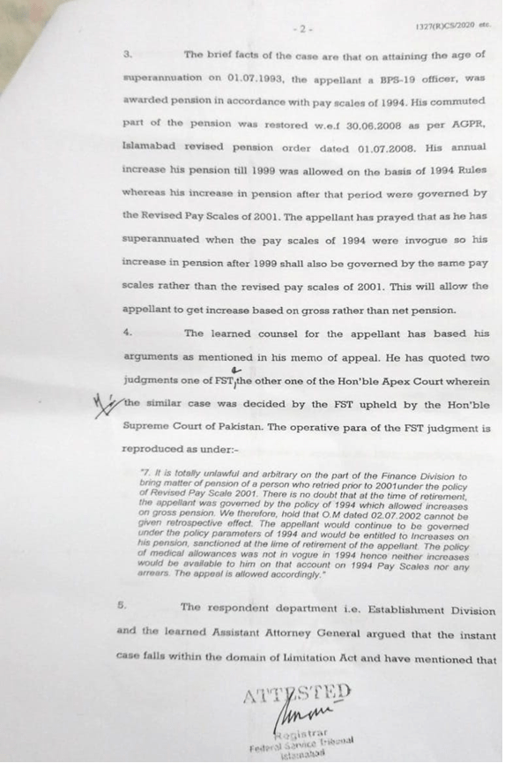

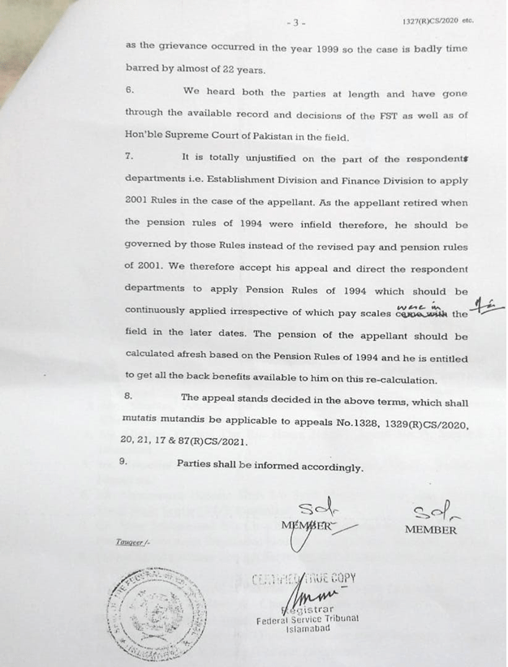

#### Implementaion Updates

Many pensioners have started enquiring when they will receive the benefit of decision of Federal Service Tribunal.  I have to explain that orders have only recently been issued by the Tribunal.  It will take a few months before the benefit is actually available.  In this connection I am giving below explanation by Agha Amir.  Callers are advised to keep in mind the facts explained hereunder and to observe time of calling.

1. **Very important and good news for pre-2001 pensioners**were published in Galaxy on 22 Jan 2022 for advance information of all those government pensioners who had retired before the introduction of 2001 payscales-cum-pension scheme.
2. It was clarified in the article that “Government has yet time to approach the Supreme Court against this decision of the FST.  The position will be clear in a month or so whether the government intends to go into appeal. Another issue is the extension of the benefit to all equally-placed pre-2001 pensioners.  It will be recollected that Supreme Court has already declared that the benefit allowed to litigating persons needs to be extended to other pensioners also who did not enter into litigation (instead of compelling them also to indulge in litigation).
3. Some pensioners got excited by the news and started asking me over phone and whatsApp how soon they will get the benefit.  I had to explain that this order by Federal Service Tribunal is the first step.  So many other steps have yet to be finalized before benefit can reach all concerned pensioners.  The intermediary steps include:
4. Appeal to Supreme Court by government against the Tribunal Orders,
5. Orders by Supreme Court,
6. Intra-court appeal if any
7. Issuing orders in favour of litigants alone, and not extending those to other equally-placed pensioners.
8. Admitting that the orders are applicable to other equally-placed pensioners, and extending the benefit to them all (instead of compelling them also to indulge into litigations)
9. Stand, if any, by provincial governments, that these orders apply to Federal government pensioners only, and not to Provincial government pensioners.
10. Efforts will be made to keep the viewers information of all developments in the matter.
11. Viewers are advised to get a copy of my latest book “Hamari Pension” which explains pension rules, orders and practices; as well as the concepts of Gross Pension, Commutation, Restoration, Increases etc.  For getting copy of the book please get in touch with Mr. Asim on 0332-5520751 or with Mr. Saeed on 0323 5041072.
12. And kindly keep in mind that I offer free opinion on pension matters.  Caller are requested to call me on working days between 0900 and 1700 hours.  Receiving calls at night is not convenient for me and my family.

Agha Amir

[amir_agha@hotmail.com](mailto:amir_agha@hotmail.com)

[amir.ahmad@aksa-sds.com](mailto:amir.ahmad@aksa-sds.com)

0300 9800246 whatsApp