**Child of the Deceased Pensioner Parents is Eligible to Two Pensions**

            Pension is a post-retirement benefit that is earned by employees through serving government and having met all prescribed conditions.  Rules provide that in case of death of the principal pensioner, the eligible family member be granted family pension, subject to relevant conditions.

1. The federal government recognizes each service in isolation for pension/family pension purposes and does not take into consideration the financial status or source of other income of the eligible family member. This is evident from clarification issued by Finance Division through O.M. No.F.2(2)2015-Reg/2015-894 dated 10 Dec 2015 (copy at A). Question No. 2 and relevant answer in the memo are reproduced below:-

### Punjab Government Policy

1. The government of Punjab has been following a different policy. Title of the family member is admitted only if there is no regular source of income.  Receipt of family pension in respect of either of pensioner parents has held a regular source of income. And the family member is considered ineligible for a family pension of the second parent.
2. When it came to notice that one Kanwal Rashid was in receipt of [two family pensions](https://www.glxspace.com/2019/04/14/judgment-of-lhc-lahore-declaring-unmarried-daughter-entitled-to-two-family-pensions-of-deceased-parents-simultaneously/) in respect of both of her parents. She was held eligible for the only pension and was asked to refund Rs.1.94 million being the pension wrongly paid in respect of the second pension. The family pensioner filed writ petition No.24111 before the Lahore High Court.

**Court Decision Regarding Two Pensions**

**This Writ Petition was allowed. It was held by the High Court that the child of the deceased pensioner’s parents is eligible to two pensions simultaneously.  Para 14 of the court orders is reproduced below for** ready reference.[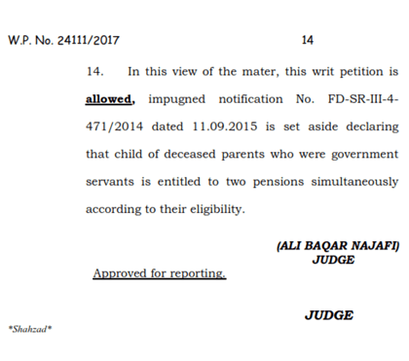](https://www.glxspace.com/2021/03/09/child-of-the-deceased-pensioner-parents-is-eligible-to-two-pensions-simultaneously/child-of-the-deceased-pensioner-parents-is-eligible-to-two-pensions-simultaneously/)

