**LINK AND GUIDANCE FOR TAX RETURN REGISTERATION**

[**https://iris.fbr.gov.pk/public/txplogin.xhtml**](https://iris.fbr.gov.pk/public/txplogin.xhtml)

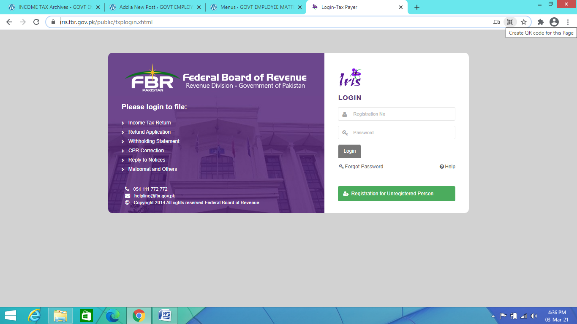

1. **If You have registered yourself then**

**In Registration Column ad CNIC Number without dashes**

**Also add Password in the next column.**

1. **If not registered, then click on last column of Registration for Unregistered Persons and provide necessary information.**

**For this purpose, it is necessary to have your own email ID and mobile phone, because for their confirmation the codes will be sent on both email ID and Mobile Phone.**